

CCT College Dublin

Assessment Cover Page

Module Title: | Machine Learning for Business
Assessment Title: | CA1
Lecturer Name: | Dr. Muhammad Iqbal
Student Full Name: | Alexandru Daniel Tarmure
Student Number: | sba24021
Assessment Due Date: | 19/04/2026
Date of Submission: | 19/04/2026

Declaration
By submitting this assessment, I confirm that I have read the CCT policy on Academic Misconduct and understand the implications of submitting work that is not my own or does not appropriately reference material taken from a third party or other source. I declare it to be my own work and that all material from third parties has been appropriately referenced. I further confirm that this work has not previously been submitted for assessment by myself or someone else in CCT College Dublin or any other higher education institution.

Machine Learning-Based Customer Segmentation and Revenue Forecasting: A Case Study of Food Delivery
PART 1
Introduction
With the ability to swiftly order meals from a variety of eateries, online food delivery services have become an indispensable element of contemporary urban living. For platforms like Foodpanda to enhance customer retention, optimize operations, and facilitate strategic decision-making, it is essential to comprehend customer behavior, order patterns, and demand dynamics. Businesses may more precisely predict future demand, identify important client categories, identify at-risk customers, and tailor marketing campaigns thanks to data-driven insights.
Problem Domain and Motivation
Food delivery businesses operate in a fiercely competitive market where operational efficiency is crucial, and client loyalty is brittle. Customer behavior is complicated and impacted by several variables, including demographics, purchasing patterns, order frequency, and satisfaction levels. Demand forecasting is crucial for resource planning since income patterns change on a daily and weekly basis. Platforms may lower churn, allocate resources more effectively, and enhance user experience by using machine learning's potent tools to identify underlying behavioral patterns and forecast future trends.
Project Objectives
Segmenting customers: To find unique client groups based on transactional and behavioral characteristics, use clustering techniques. These groups can help with churn prevention tactics, tailored recommendations, and targeted marketing.
Revenue Forecasting: Develop time series models (ARIMA/SARIMA) to analyse daily revenue patterns, detect seasonality, and generate short‑term forecasts that support operational planning and strategic decision‑making.
Dataset description
This project uses a Foodpanda-style transactional dataset containing customer, order, and delivery information. Key variables include customer demographics (gender, age, city), account details (signup_date, loyalty_points, churned), order information (order_id, order_date, restaurant_name, dish_name, category, quantity, price, payment_method, order_frequency, last_order_date), and service quality indicators (rating, rating_date, delivery_status). From these, additional features such as order_value and a binary churn_flag were engineered to support analysis.
Data Preparation and Exploration
Data Cleaning
Inconsistent missing value marks like "?" "Na", "Unknown", and blank spaces were present in the dataset. These were suitably imputed and standardized to NaN:
The median, which is resistant to outliers, is used to impute numerical variables.
Mode is used to impute categorical data while maintaining the most prevalent category.
Duplicates were eliminated.
To prevent indexing problems, trailing spaces were removed from column names.
This guaranteed a consistent, clean dataset that could be used for modeling.
Dataset Structure
After cleaning, there are 6000 entries with no missing values.
Quantity, price, order frequency, loyalty points, and rating are the five numerical columns.
15 categorized columns: payment method, restaurant information, customer demographics, etc.
The eligibility for clustering was confirmed by describing (), which revealed a significant variety in numerical variables.
PART 2
K-Means: it's easy to use, effective, decent baseline, assuming roughly spherical clusters.
Agglomerative: hierarchical, does not require centroids to be predetermined, and can capture non-spherical shapes.
DBSCAN: density-based, detects any form, manages outliers and noise.
GMM: elliptical clusters, probabilistic, soft assignments that work well for behavioral segments that overlap.
Customer Segmentation Using Clustering
Selection of Features
The behavioral characteristics listed below were chosen for clustering:
quantity, price, order frequency, loyalty points, and rating
These characteristics are crucial for consumer segmentation since they record purchase intensity, spending patterns, engagement, and satisfaction.
Standardisation
Distance measures are essential to clustering algorithms. In order to avoid the dominance of high magnitude factors (like price), all attributes were standardized using:
StandardScaler() in Python
This guarantees that every feature contributes equally.

Compare K values, DBI, and Silhouette Score to the number of clusters.
To guarantee equal contribution to Euclidean distances, which is crucial for K-Means, the code standardizes all features using StandardScaler. The cluster counts 𝑘=2–9 are then assessed by repeatedly fitting K-Means and calculating two internal validity metrics: the Davies–Bouldin Index (lower implies more compact, well-separated clusters) and the Silhouette Score (higher indicates better cohesion and separation). The figures demonstrate that DBI continuously declines as 𝑘 grows, showing increased compactness with additional clusters, whereas Silhouette values stay low (0.14–0.19), demonstrating weak natural separation. These findings collectively suggest that there is no strong ideal 𝑘, although a higher 𝑘 offers somewhat better structure, necessitating a trade-off between practical interpretability and statistical improvement. GeeksforGeeks (2023).
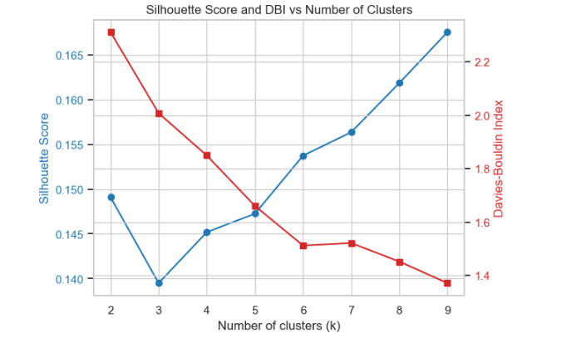

Evaluate Silhouette & DBI vs K and Compare models
Cluster quality was assessed across a range of 𝑘 values using the Davies–Bouldin Index (lower is better) and Silhouette Score (higher is better). A balanced choice of 𝑘 can be found by plotting both metrics; 𝑘 = 4 was chosen since it offers a respectable amount of structure without unduly fragmenting the dataset. For comparison, K-Means and Agglomerative clustering were fitted using this value.
The outcomes unequivocally demonstrate that K-Means works better than agglomerative clustering. While Agglomerative clustering yields a much lower Silhouette Score of 0.0795 and a higher DBI of 2.2712, K-Means achieves a Silhouette Score of 0.4151 and a DBI of 1.8491. These measurements show that K-Means creates more compact and well-defined clusters since higher Silhouette values and lower DBI values suggest greater cohesion and separation. Agglomerative clustering, on the other hand, finds it difficult to find significant structure in this dataset, which leads to poorly divided groups.
Overall, K-Means is the approach of choice for additional consumer analysis since it offers the most reliable and comprehensible segmentation. Datasciencebase.com. (2025).
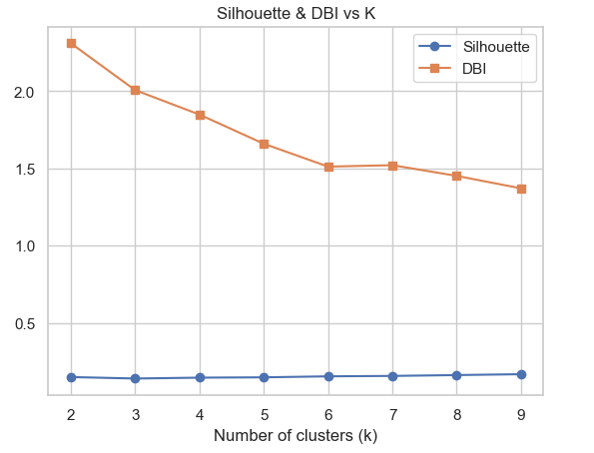

K-Means Clusters with PCA
Examine and evaluate the K-Means clustering findings. PCA is applied to the standardized dataset in the first section. Many correlated variables are reduced by PCA to two main components that account for the majority of the variance. Every observation is projected onto a two-dimensional space using fit_transform and PCA(n_components=2). The scatterplot allows for the visual evaluation of separation, compactness, and overlap by using color to represent each K-Means cluster. Clusters may indicate substantial structure if they form discrete color groups; if they heavily overlap, the clustering may be weaker. Without dimensionality reduction, high-dimensional data cannot be visually comprehended, which makes this step crucial.

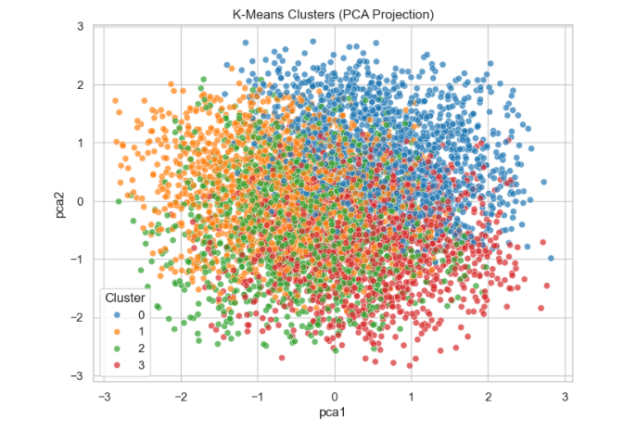

Creates cluster profiles by calculating the average of each cluster's important behavioral characteristics, including quantity, price, order frequency, loyalty points, and rating. The differences between clusters on a standardized scale can be seen by plotting the transposed table as a bar chart. For instance, one cluster can have low order frequency but high loyalty points, while another might make frequent purchases but have poor product ratings. Kaloyanova, E. (2020).
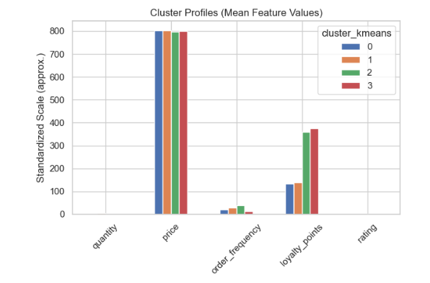
PART 3
Time Series Preprocessing and ADF Stationarity Results
By utilizing pd.to_datetime() to convert the order_date column into a datetime format, forcing incorrect entries to NaT. This guarantees that following time-series operations work properly and that the dataset may be indexed chronologically. To preserve a tidy temporal structure, rows with invalid dates are then eliminated. Price and quantity are multiplied to form a revenue variable, which is a numerical measure that can be aggregated and analyzed. The daily revenue is calculated by adding up the revenue for each day after grouping transactions by order_date. The resultant series is given a daily frequency using.asfreq('D') and sorted chronologically. This step guarantees that all calendar days, including those with no orders logged, are included in the time index. Time-series models that depend on uniformly spaced observations and regular lag intervals must explicitly reflect missing days. With revenue numbers ranging from almost zero to roughly 60,000, the depicted time series exhibits significant daily volatility. There is no discernible long-term upward or negative trend, and the swings seem erratic. Although this visual examination raises the potential of stationarity, a rigorous statistical test is necessary to verify it.The daily income series is subjected to the Augmented Dickey–Fuller (ADF) test (after missing values are eliminated). The test yields a p-value of 0.000 and an ADF statistic of −26.48. The unit root null hypothesis is rejected since the statistic is significantly below the 1%, 5%, and 10% critical levels. This shows that there is no need for differencing because the daily income series is stationary. Because the series already meets the stationarity criteria, these results support the use of ARIMA models with 𝑑 = 0. Together, the statistical test and preprocessing procedures verify that the dataset is appropriately organized for further forecasting. Gen.David L (2023).
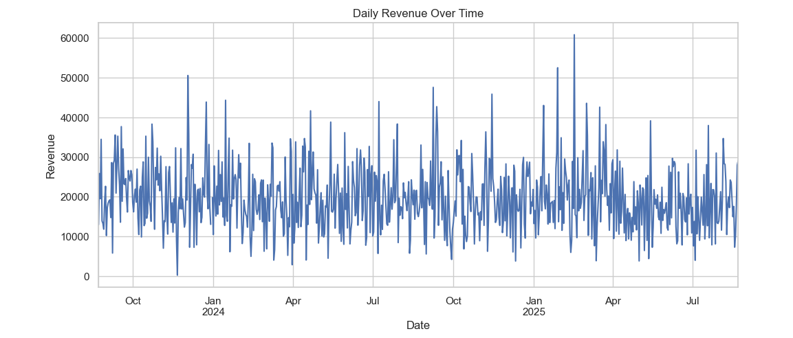

Differencing eliminates level shifts and isolates short-term variations, as evidenced by the differenced daily income series' narrow fluctuations around zero. The graphic displays high-frequency variability, with abrupt increases or decreases in revenue from one day to the next indicated by sharp positive and negative spikes. The differenced series may be mean-stable if there are no discernible trends or drift. Differencing is usually employed to attain stationarity, but since the original series was already stationary, it primarily functions as a diagnostic in this instance.
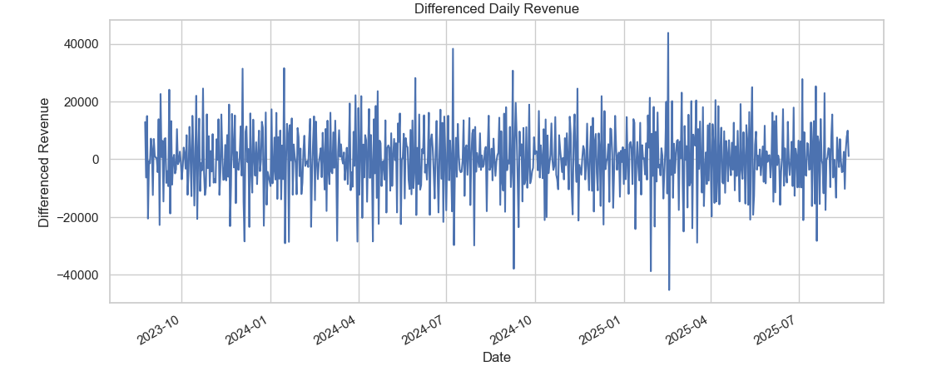

STATIONARITY TEST
The daily income series is subjected to the Augmented Dickey–Fuller (ADF) test to evaluate stationarity, which is a need for ARIMA modeling. The series is stable, as demonstrated by the ADF statistic of –26.48 with a p-value of 0.0, which strongly refutes the null hypothesis of a unit root. Appropriate ARIMA parameters can be found using the ACF and PACF graphs of the differenced revenue that follow. The PACF exhibits a strong spike at lag 1 followed by a sharp decline, but the ACF shows very little meaningful autocorrelation after lag 1. An ARIMA model with d = 0 and a tiny AR or MA component is usually supported by this pattern, which indicates a low-order autoregressive structure. ScienceInsights. (2026).

TRAIN-TEST SPLIT: Daily revenue forecasts using ARIMA modeling.
For time-series analysis, the dataset must first be divided chronologically into an 80% training set and a 20% test set because shuffling would eliminate temporal dependencies. In order to guarantee that the ARIMA model receives a consistent, gap-free DatetimeIndex, the frequency is therefore imposed as daily. The differencing order is appropriately chosen to d = 0 since the Augmented Dickey-Fuller test already verified strong stationarity (p-value = 0.0). The ACF and PACF patterns, which exhibit weak but non-random short-lag autocorrelation and suggest that a low-order ARMA structure is suitable, support the ARIMA(1,0,1) specification. The steady average revenue level is reflected in the model summary's highly significant constant term. The series appears to have little autoregressive or moving-average structure, though, as both the AR(1) and MA(1) coefficients are statistically negligible. This is consistent with the rapid decay of correlations observed in the earlier ACF/PACF data. Rather than model instability, the high sigma² value is a reflection of daily revenue's inherent fluctuation. Overall, the findings show that the revenue series is stationary with little temporal dependence, and ARIMA(1,0,1) offers a suitable yet straightforward forecasting framework that is in line with the properties of the data. Github.io. (2019).

ARIMA modeling Visualisation
The forecasting algorithm creates out-of-sample forecasts for the test period using the fitted ARIMA model. To provide a fair comparison between expected and actual values, the command results.forecast(steps=len(test)) generates a one-step-ahead forecast for every point in the test set. In order to visually evaluate how effectively the model reflects the revenue dynamics, the training data, test data, and anticipated values are superimposed in the following plot. For assessing trend consistency, deviation patterns, and temporal alignment, this visualization is crucial.
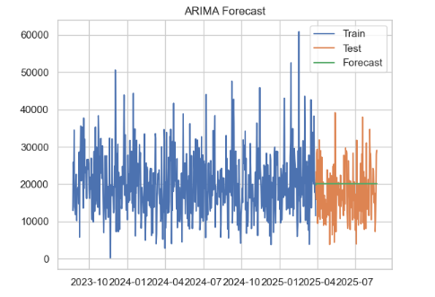
Mean Absolute Error (MAE) and Root Mean Squared Error (RMSE) to measure accuracy. While RMSE penalizes greater deviations more severely, MAE measures the average magnitude of forecast errors. The results show moderate forecasting accuracy (MAE = 6163 and RMSE = 7464), which is in line with the previous conclusion that the ARIMA(1,0,1) model has weak autoregressive structure. These findings make sense in light of the data's low autocorrelation: the model accurately depicts the overall revenue level but is unable to accurately forecast short-term variations. For evaluating ARIMA performance on stationary revenue data, the forecasting process and assessment criteria are generally suitable and methodologically sound. Prabhakaran, S. (2021).

Seasonal Decomposition
Examine whether there is a consistent weekly trend in the daily revenue data. To provide a continuous time series appropriate for decomposition, missing values are first eliminated. The program then applies the seasonal_decompose function with model="additive" and period=7, assuming that the observed income is composed of residual noise, a recurring 7-day seasonal cycle, and a trend component. Because the seasonal changes seem to have a roughly constant amplitude throughout time, an additive model makes sense.Weekly seasonality is evident in the resulting four-panel figure. The trend component shows the long-term revenue trajectory throughout the 2023–2025 period while mitigating short-term variations. The seasonal component has a regular, recurring weekly pattern with comparable peaks and troughs every week, which corresponds with normal demand cycles in food delivery companies. The trend and seasonal structure have been successfully recorded, as evidenced by the residual component's mostly random oscillation around zero.
The employment of a SARIMA model with a seasonal period of seven for forecasting is justified by the decomposition, which verifies that the data shows a robust and consistent weekly seasonal pattern. Brownlee, J. (2017).
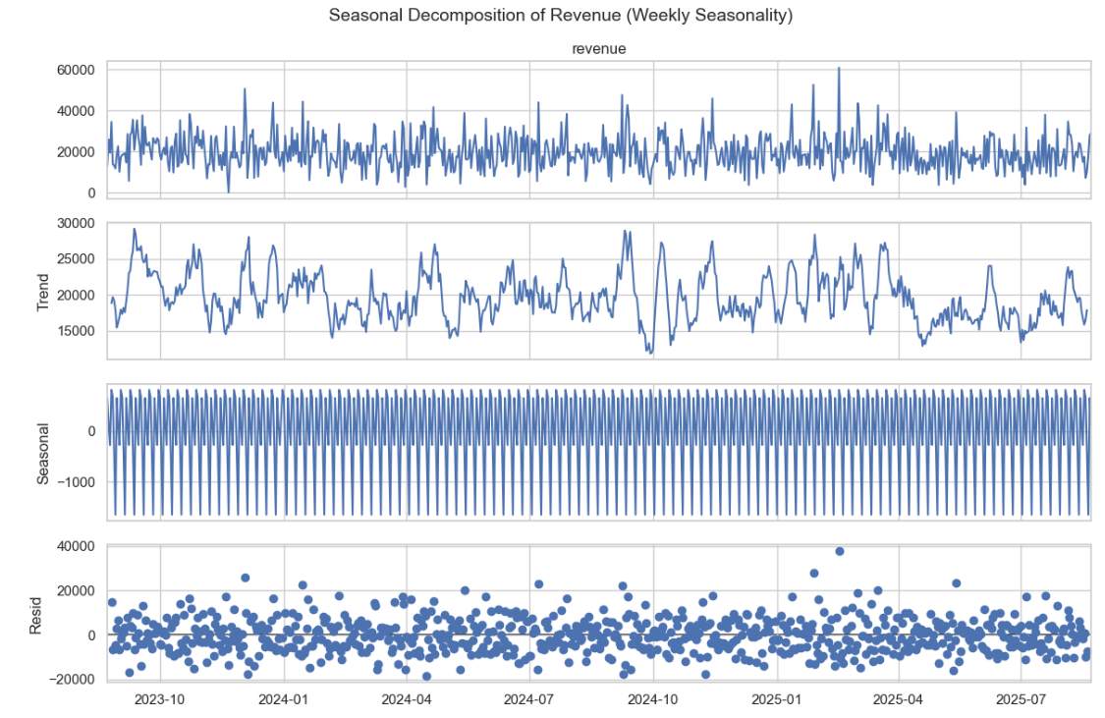

Fit SARIMA Model
In order to capture both weekly seasonality and short-term autocorrelation, a Seasonal ARIMA model was applied to the training component of the revenue time series. One autoregressive term, one moving-average term, and a seasonal AR and MA component that repeats every seven days make up the model's specification, which is SARIMAX(train, order=(1,0,1), seasonal_order=(1,0,1,7)). In order to enable the model to converge even when parameters are close to the boundary of the parameter space, stationarity and invertibility constraints are turned off. Key diagnostics are reported in the model summary. When comparing different SARIMA configurations, the AIC value (12064) offers a measure of model fit. The Ljung-Box test yields a non-significant p-value, indicating that the model captures the majority of temporal structure and residual autocorrelation is low. Although non-normal residuals are frequently found in real-world revenue data, the Jarque-Bera test does not invalidate forecasting. Covariance matrix warnings indicate parameter instability, which is frequently caused by modest AR/MA effects.
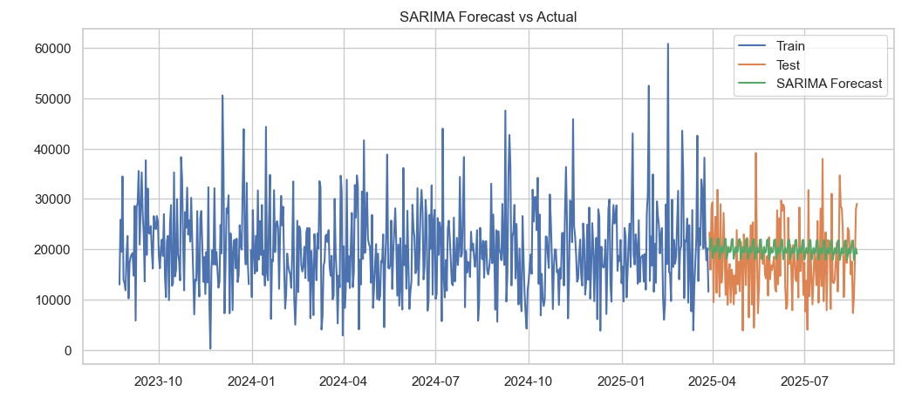
The forecast plot contrasts the test set with the model's predictions. The SARIMA forecast captures the overall level and weekly changes while tracking the general direction of the actual values. This shows that the model provides a solid short-term forecasting baseline and effectively learns the previously known seasonal trend. Thor, W.-M. (2026).
DBSCAN Clustering
After assessing the SARIMA model's performance, the algorithm uses DBSCAN to investigate any natural groups within the dataset. First, MAE and RMSE are used to measure the accuracy of the SARIMA forecast. The values (MAE 6308, RMSE 7540) show a moderate forecasting inaccuracy, indicating that SARIMA catches weekly patterns but not all swings and reflecting the variability in revenue data.
DBSCAN is a sophisticated clustering technique. Instead of using predetermined cluster counts, DBSCAN uses density to identify clusters. A point must have at least 10 neighbors within a radius of 0.8 (in scaled feature space) in order to generate a dense region, according to the parameters eps=0.8 and min_samples=10. Following fitting, DBSCAN labels each point: -1 for noise points and 0 for the single recognized cluster. DBSCAN discovered a single dense cluster and multiple outliers, as shown by the output's two labels, 0 and -1.
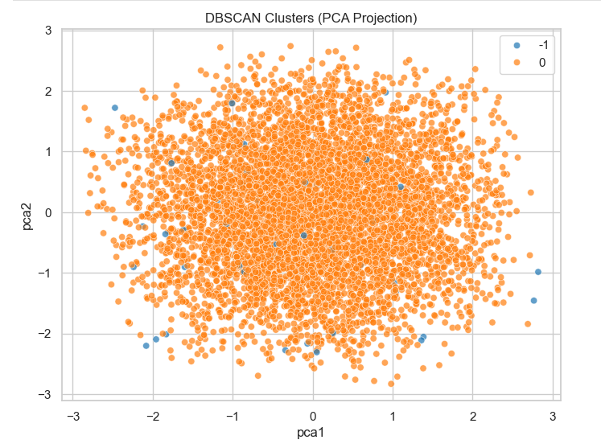
Since the metric requires at least two clusters, the silhouette score cannot be calculated because there is only one valid cluster. This is supported by the PCA scatter plot, which shows that noise points are dispersed throughout and the majority of points fall into a single, sizable cluster. This shows that with the selected settings, the dataset does not automatically split into several density-based groups. GeeksforGeeks (2019).

Gaussian Mixture Model (GMM) Clustering
To find latent consumer segments, apply the Gaussian Mixture Model (GMM) to the scaled dataset. GMM is used because, in contrast to K-Means, it captures elliptical, overlapping cluster geometries and allows soft assignments by modeling clusters as probabilistic Gaussian distributions. This makes sense for behavioral data from the actual world, since group boundaries are rarely exactly spherical or sharply divided. In order to allow each cluster to discover its own shape, the first block initializes a GMM with four components and complete covariance matrices. Cluster labels are then predicted by the model and saved in the dataset for later examination. The assessment measures cluster quality using the Davies-Bouldin Index (DBI) and Silhouette Score. Weak separation, or significant cluster overlap, is indicated by the Silhouette score of 0.134. This is further supported by the DBI of 2.087, since compact, well-separated clusters are generally indicated by lower values (<1). These findings imply that although GMM is capable of simulating intricate structures, strong, identifiable groups are not naturally formed in the underlying data.
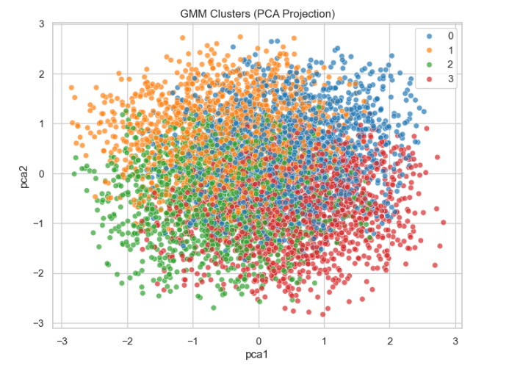

The clusters are shown in two dimensions by the PCA scatter plot. The overlapping colors support the numerical measurements, which show that clusters are present but not clearly defined. This lends credence to the finding that consumer behavior in this dataset is not strongly segregated but rather continuous. Noble, J. (2025).

LINK ACCESS TO VIDEO: https://drive.google.com/file/d/1jJaGMKSWaft9td3GtKXpMhVFZMBST9jX/view?usp=sharing

References
DATA SET LINK: https://www.kaggle.com/datasets/ayeshaimran1619/foodpanda-data-analysis
GeeksforGeeks (2023). Clustering Metrics in Machine Learning. [online] GeeksforGeeks. Available at:
https://www.geeksforgeeks.org/machine-learning/clustering-metrics/.
Datasciencebase.com. (2025). Evaluation Metrics for Unsupervised Learning | DataScienceBase. [online] Available at: https://www.datasciencebase.com/unsupervised-ml/advanced-clustering-topics/evaluation-metrix-usvml/.
Kaloyanova, E. (2020). How to Combine PCA and K-means Clustering in Python? [online] 365 Data Science. Available at: https://365datascience.com/tutorials/python-tutorials/pca-k-means/.
Gen. David L (2023). Guide to Time Series Data Pre-processing Methods - Gen. David L. - Medium. [online] Medium. Available at:
https://medium.com/@tubelwj/guide-to-time-series-data-pre-processing-methods-0a6df7ee054f.
ScienceInsights. (2026). Stationarity in Time Series: Definition, Types, and Tests. [online] Available at:
https://scienceinsights.org/stationarity-in-time-series-definition-types-and-tests/.
Github.io. (2019). ARIMA Modeling and Train/Test Split - Lauren Writes. [online] Available at: https://laurenliz22.github.io/arima_modeling_and_train_test_split.
Prabhakaran, S. (2021). ARIMA Model - Complete Guide to Time Series Forecasting in Python | ML+. [online] machinelearningplus. Available at:
https://machinelearningplus.com/time-series/arima-model-time-series-forecasting-python/.
Brownlee, J. (2017). How to Decompose Time Series Data into Trend and Seasonality. [online] Machine Learning Mastery. Available at:
https://machinelearningmastery.com/decompose-time-series-data-trend-seasonality/.
Thor, W.-M. (2026). Fitting SARIMA Models in Python. [online] Apxml.com. Available at: https://apxml.com/courses/time-series-analysis-forecasting/chapter-5-seasonal-arima-sarima/fitting-sarima-python.
GeeksforGeeks (2019). DBSCAN Clustering in ML Density based clustering. [online] GeeksforGeeks. Available at: https://www.geeksforgeeks.org/machine-learning/dbscan-clustering-in-ml-density-based-clustering/.
Noble, J. (2025). Gaussian mixture model. [online] Ibm.com. Available at: https://www.ibm.com/think/topics/gaussian-mixture-model.

